ELEC 552 Proj4 CORDIC

1. HLS Design

The HLS implement of CORDIC contain mainly four sections:

The first section is angle correction to make sure that for the sin/cos mode, the rotation angle is within [-2/pi, 2/pi] to make sure that the result fit in 16bit with 13bit fraction. For the arctan mode, the initial vector is rotated to make sure it’s in the first and fourth quadrant.

The second section is rotation. We use a look up table containing the first 32 rotation angles to perform a loop that rotate the vector 32 times. We utilize the HLS PIPELINE to pipeline the loops. We pick plus and minus the shifted x, y value according to whether the current angle is smaller than the target angle(sin/cos mode) or the current y value is smaller than 0(arctan mode). The signs are hard-coded to avoid multiplication.

The third section is scaling correction. This section use 7 oscillating positive and negative hard-coded scaling factor to correct the scaling change due to rotation. We utilize the HLS PIELINE to pipeline this section

The last section refer back to the first section. After changing the target angle or sin/cos values, in the end to we need to correct the sign(sin/cos mode) or the angles(arctan mode) is any angle correction happened in the first section.

1. HLS Output

**SIN/COS Mode:**

CORDIC sin=0.000366, cos=0.998169

degree=0, radian=0.000000, sin=0.000000, cos=1.000000

CORDIC sin=0.258667, cos=0.964111

degree=15, radian=0.261719, sin=0.258741, cos=0.965947

CORDIC sin=0.499023, cos=0.864258

degree=30, radian=0.523560, sin=0.499966, cos=0.866045

CORDIC sin=0.705688, cos=0.705688

degree=45, radian=0.785278, sin=0.707022, cos=0.707192

CORDIC sin=0.864258, cos=0.499023

degree=60, radian=1.047119, sin=0.865986, cos=0.500068

CORDIC sin=0.964111, cos=0.258667

degree=75, radian=1.308960, sin=0.965916, cos=0.258855

CORDIC sin=0.996582, cos=-0.000366

degree=90, radian=1.570679, sin=1.000000, cos=0.000118

**Average Error for Sin: 0.002624**

**Average Error for Cos: 0.002157**

**ArcTAN Mode:**

degree=0, radian=0.000000, sin=0.000000, cos=1.000000

CORDIC radian=0.000244, sin=0.000000, cos=0.999634

degree=15, radian=0.261719, sin=0.258667, cos=0.965942

CORDIC radian=0.261475, sin=0.000000, cos=0.998047

degree=30, radian=0.523560, sin=0.499878, cos=0.865967

CORDIC radian=0.523438, sin=0.000000, cos=0.999390

degree=45, radian=0.785278, sin=0.706909, cos=0.707153

CORDIC radian=0.785156, sin=0.000122, cos=0.998047

degree=60, radian=1.047119, sin=0.865967, cos=0.500000

CORDIC radian=1.047119, sin=0.000000, cos=0.999390

degree=75, radian=1.308960, sin=0.965820, cos=0.258789

CORDIC radian=1.309082, sin=0.000000, cos=0.998169

degree=90, radian=1.570679, sin=0.999878, cos=0.000000

CORDIC radian=1.570312, sin=0.000000, cos=0.997925

**Average Error for arcTan: 0.002901**

1. HLS performance

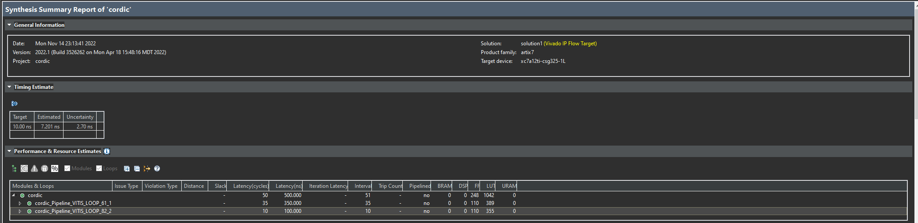

1. Model Composer

